17 January 2019

Dear Parent/Carer

ELECTION OF PARENT GOVERNOR

I am writing to inform you that we currently have a vacancy for a parent governor on the Greenshaw High School Governing Body.

There is provision for 2 parent governors on the governing body, to work alongside other governors representing school staff, as well as governors appointed by the Greenshaw Learning Trust Board of Trustees and by the governing body itself. There is currently a total of 10 governors.

The role of the school governor is both rewarding to the individual and invaluable to the school. You will need to be supportive of the values of the school and be able to give time and effort to further its ongoing development; support and training is provided.

No specific experience is required; however, the governing body would particularly welcome applications from parents with previous governor experience, or with experience in either education, other public sector settings, finance or business sectors.

As a governor you will be expected to attend meetings and take an active part in them, help the governing body make informed decisions, and get involved with the school and its pupils. The governing body normally meets 6 times a year, in the evening. You will also be asked to take on particular tasks in relation to the work of the governing body, such as being a Lead Governor for a specific area of school development, or to be part of ad-hoc sub committees of the governing body.

There are rules on a person’s eligibility to be a governor, e.g. relating to bankruptcy and criminal convictions, and requirements on disclosure of interests and involvement in other bodies that could impact on the work of the Greenshaw Learning Trust or the school.

For further information on the role of and requirements of a school governor, please see the attached guide.

Parents wishing to stand for election are asked to complete the application form enclosed or download it from the school website at www.greenshaw.co.uk. Application forms must be returned to the school, marked for the attention of the Head of Clerking, Greenshaw Learning Trust, by the closing date of Monday 4th February at 9.00 a.m.

If more than one application is received, a ballot will be held in which all parents and carers may vote; in these circumstances the applicants’ personal statements will be made available to all parents/carers to inform their vote.

Should you require further information, please don’t hesitate to contact me on the email address below.

Yours sincerely
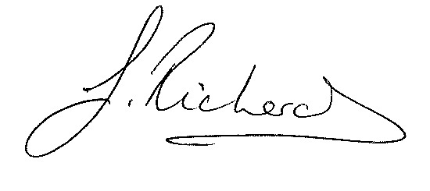
pp
Maria Foster

Clerk to the Governing Body

mfoster@greenshaw.co.uk

Enclosures:

Application form

Guide to being a school governor
Code of conduct
Declaration of Interests Policy

